Performance Engineering

*[Subtitle]*

[Document type]

Author: Xingrong Zong

Supervisor: [Supervisor]

Semester: VT21

Course code: 2DV608

Table of contents

1 Introduction 4

2 Calculations 4

2.1 Web Server 5

2.2 Application Server 5

2.3 Database 6

2.4 User Thinking 6

2.5 Card Payment Server 6

2.6 Voucher Payment Server 6

3 Model 7

3.1 Service Time 7

3.1.1 Web Server 7

3.1.2 Application Server 8

3.1.3 Database 8

3.1.4 CardPayment Server 9

3.1.5 VoucherPayment Server 9

3.2 Routing Probabilities 10

3.2.1 Database 10

3.2.2 User Thinking 10

3.2.3 CardPayment Server 11

3.2.4 VoucherPayment Server 11

3.3 Resources 11

3.4 System Number of Customers 12

3.5 System Response Time 12

3.6 System Throughput 13

3.7 Residence Time 13

3.8 Utilization 14

3.9 Throughput 15

3.10 Response Time 16

# Introduction

This report shows the results of the mathematical representation of the behaviour from the system proposed, a model created with JMT and the results got by it.

# Calculations

|  |  |  |  |
| --- | --- | --- | --- |
| **Server** | **S** | **X** | **U** |
| Web Server | 0.06 |  |  |
| Application Server | 0.25 | 3.125 | 0.7812 |
| Database | 0.035 |  |  |
| User Thinking |  |  |  |
| Card Payment Server | 0.2 |  |  |
| Voucher Payment Server | 0.075 | 3 | 0.225 |

## Web Server

## Application Server

## Database

## User Thinking

## Card Payment Server

## Voucher Payment Server

# Model

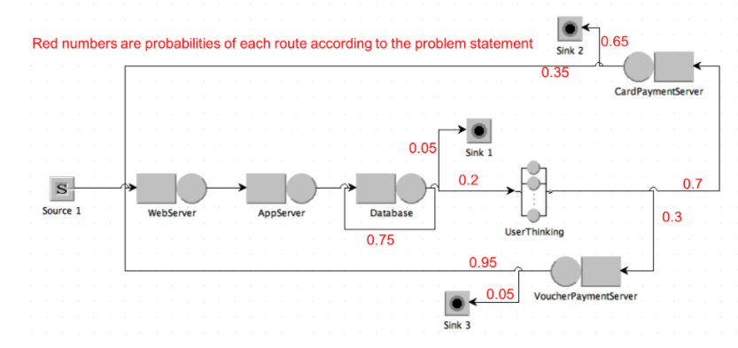

## Service Time

### Source 1

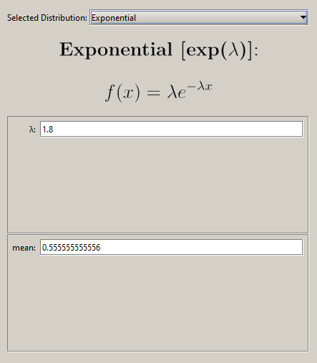

### Web Server

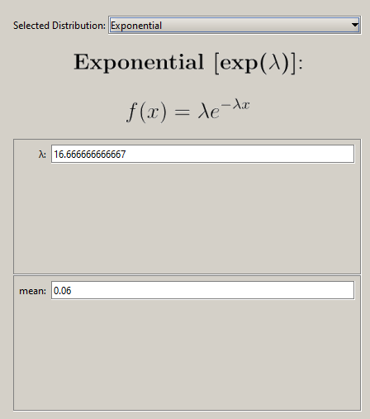

### Application Server

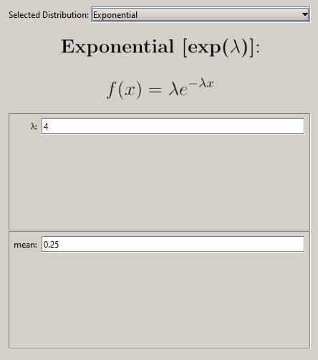

### Database

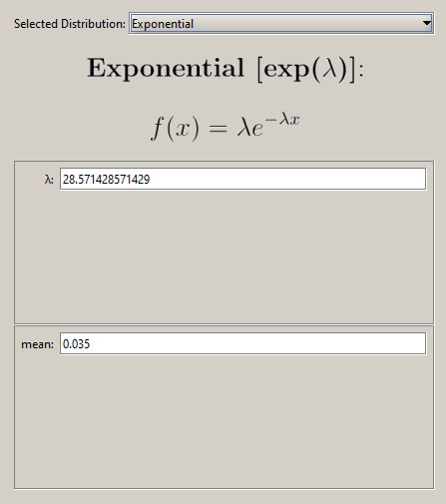

### CardPayment Server

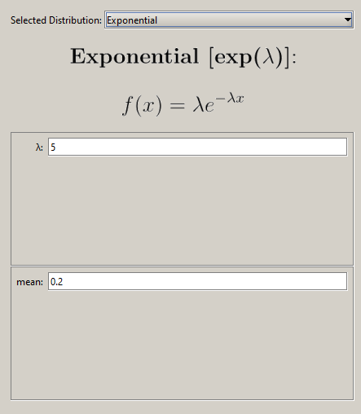

### VoucherPayment Server

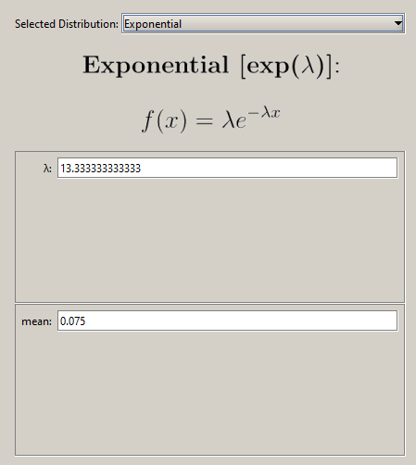

## Routing Probabilities

### Database

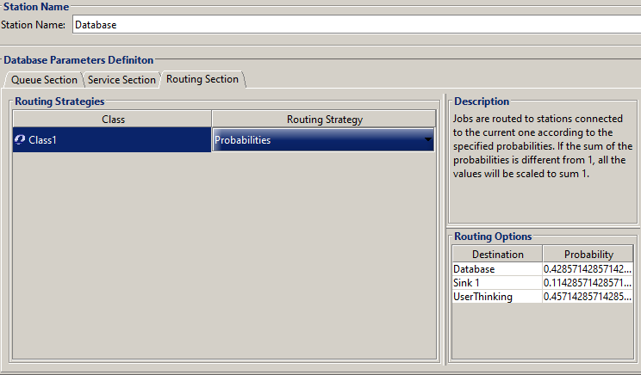

### User Thinking

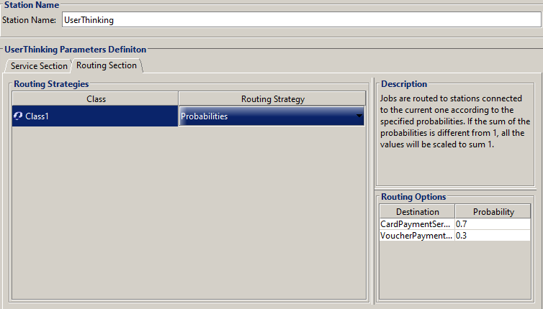

### CardPayment Server

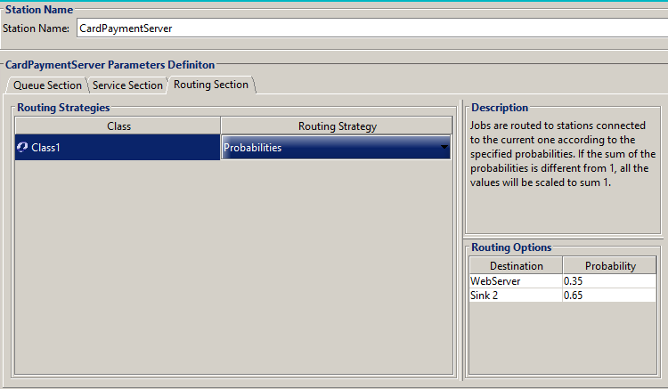

### VoucherPayment Server

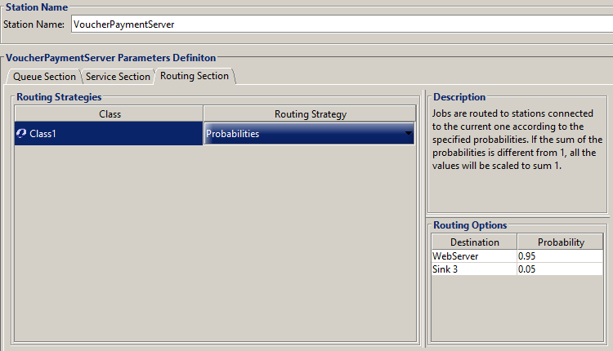

|  |  |  |  |
| --- | --- | --- | --- |
| Name of service center | Utilization | Throughput | Residence |
| *WebServer* | **0.1898** | **3.1533** | **0.1276** |
| *ApplicationServer* | **0.7814** | **3.1449** | **1.9991** |
| *Database* | **0.1107** | **3.1449** | **0.0688** |
| *CardPaymentServer* | **0.3510** | **1.7599** | **0.3039** |
| *VoucherPaymentServer* | **0.0565** | **0.7521** | **0.0332** |

Average System Reponse Time (3.68E4~3.85E4): 3.8914

Average System Number of Customer (2.6172~2.7389): 7.0765

Average System Throughput (0.9801~1.0365): 1.8013

Average time that a user is waiting for a reply from the system:

## System Number of Customers

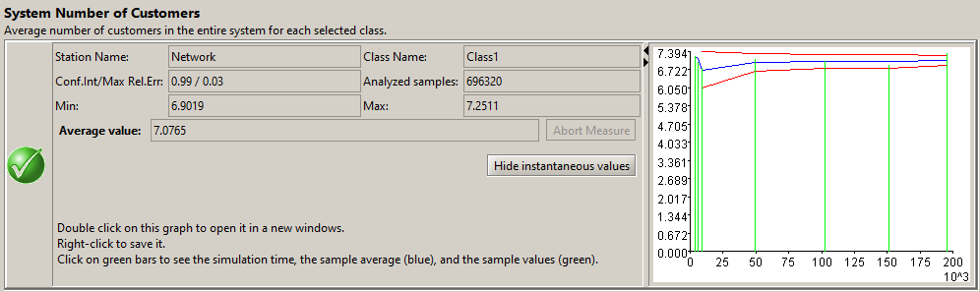

## System Response Time

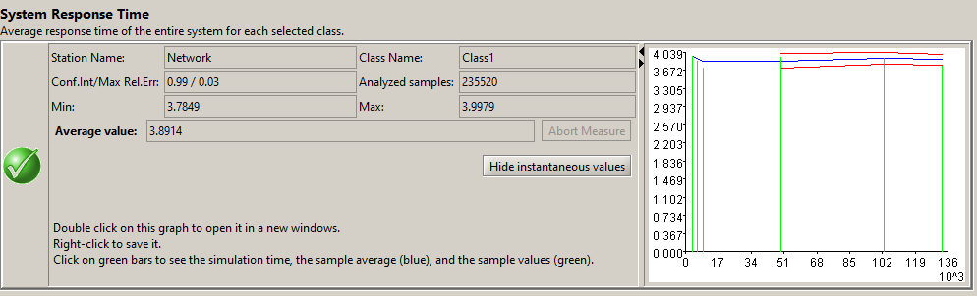

## System Throughput

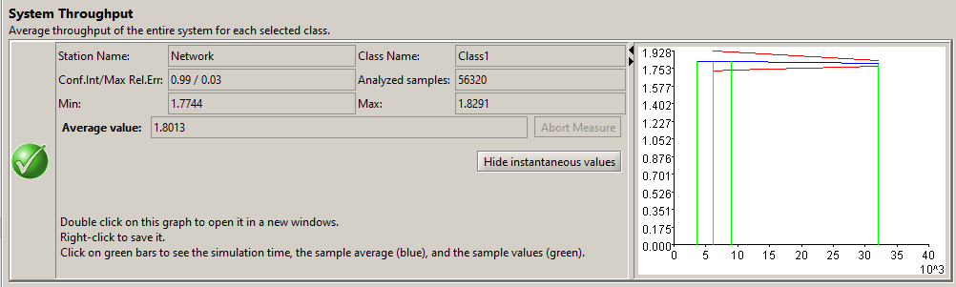

## Residence Time

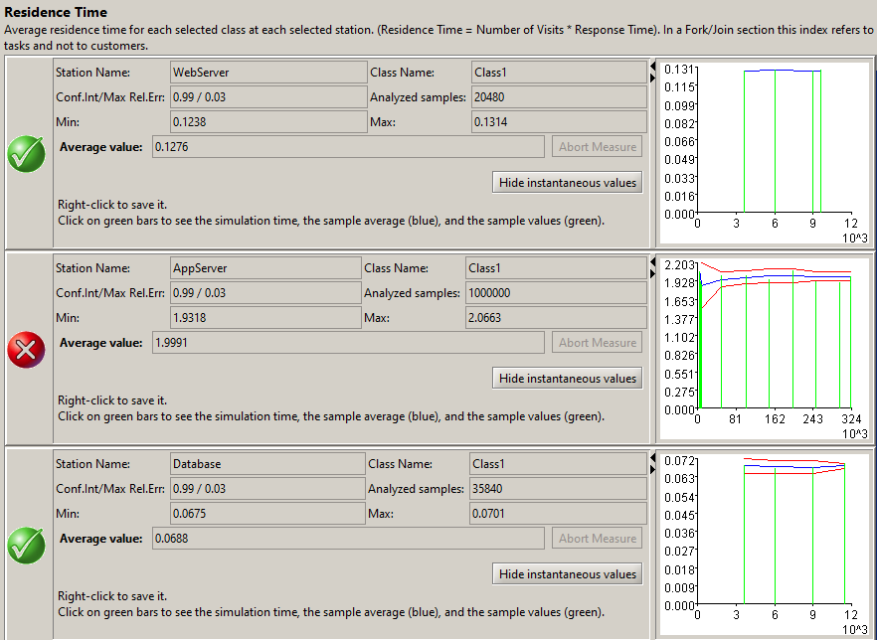

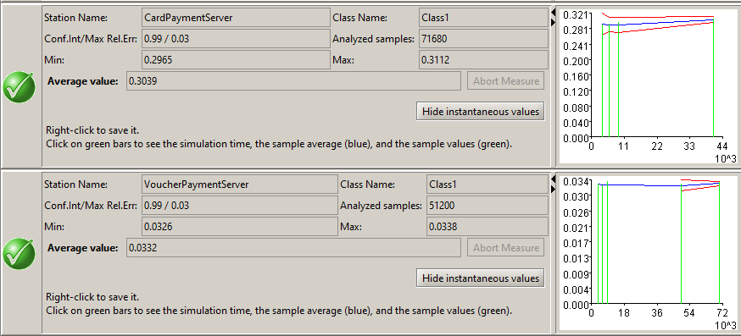

## Utilization

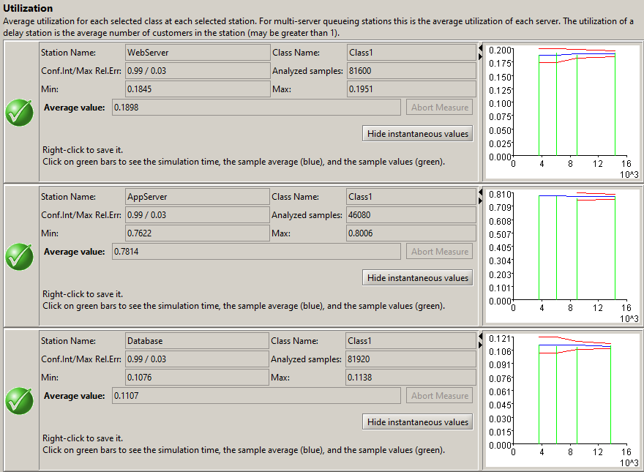 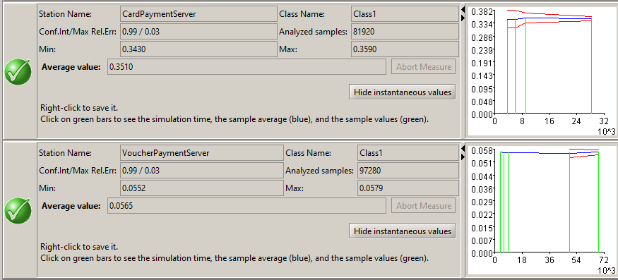

## Throughput

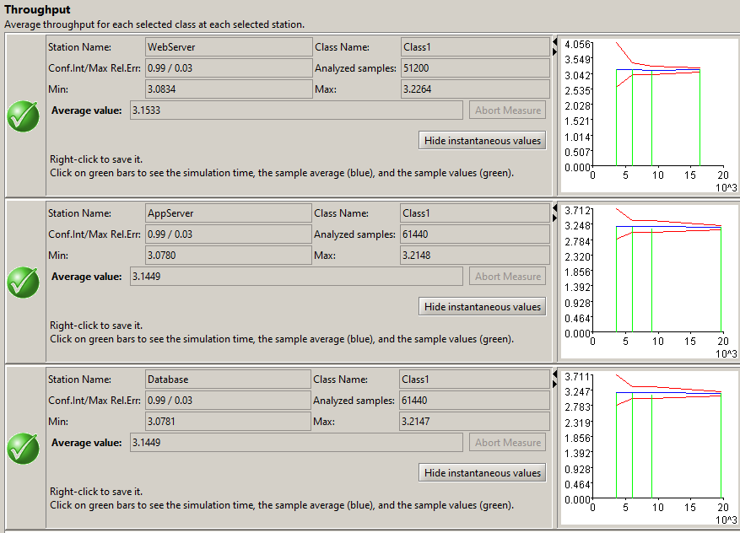 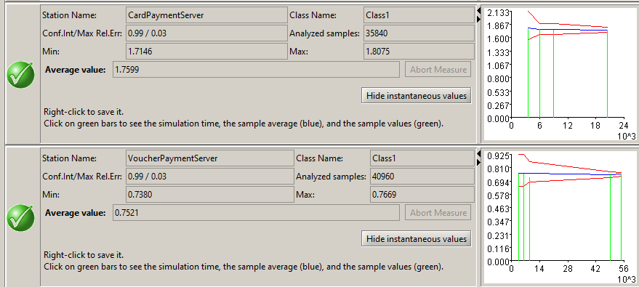

## Response Time

